Original Article

Fabrication of Bio -adhesive Gel for Skin Surgery: In Vitro and In Vivo study

Hanieh Beiranvand ¹-, Simin Farokhi ²-, Bahram Rasoulian ³-, Sodabeh Zare ⁴-, *Farzaneh Chehelcheraghi ⁵-, *Marzieh Rashidipour ⁶
1. Student Research Committee, Lorestan University of Medical Sciences, Khorramabad, Iran
2. USERN Office, Lorestan University of Medical Sciences, Khorramabad, Iran
3. Neurophysiology Research Center, Institute of Neuroscience and Cognition and Department of Physiology, School of Medicine, Shahid Beheshti University of Medical Sciences, Tehran, Iran.
4. Nutritional Health Research Center, Lorestan University of Medical Sciences, Khorramabad, Iran
5. Gastroenterology and Liver Diseases Research Center, Research Institute for Gastroenterology and Liver Diseases, Shahid Beheshti University of Medical Sciences, Tehran, Iran,
6. Nutritional Health Research Center, Lorestan University of Medical Sciences, Khorramabad, Iran.
* First Corresponding Authors: Email: fr.Chehelcheraghi@gmail.com,
Chehelcheraghi.farzaneh@sbmu.ac.ir
*Second Corresponding Authors: Email: m_rashidi80@yahoo.com

Abstract
Background: Using natural compounds can overcome the disruption of traditional sutures and the problems of tissue adhesives in the wound healing process, the biomedical market has seen many effective skin products but many of them are still have limited. We aimed to use both herbal essential oil and gels to fabricate and study a new oleoresin essential oil of wild pistachio tree Tragacanth resin xerogel-like Bio-adhesive for skin surgery. Its low stiffness, scaffold-based matrix due to the gel part it can facilitate wound healing.
Methods: Different concentrations of resin 6-9 w/v and essential oils 0.2 -1 w/v were blended according to the response surface methodology using the central composite design. The attachments were fabricated using the freeze-drying technique. These were assessed physically and biologically cell viability, cell attachment, SEM, FTIR techniques and in vivo a mouse incision injection model.
Results: Tragacanth resin is an adhesive agent glue. The gel part could affect the physical properties of attachments including FTIR, the strong peak at 1638.57 cm⁻¹ and Particle size including SEM Mean ±Std Dev; 47 ±0.89 µm. Also, it demonstrated no cytotoxicity towards H-Fib cells, 80% cell viability with good attachment, and cell concentration justified by the gel content. It showed good in vivo biocompatibility.
Conclusion: Fabricated Bio-adhesive gel-like attached with essential oil of wild pistachio content can be a good candidate for regeneration-skin-based surgical purposes. However more in vitro and in vivo revisions are mandatory to adjust the herbal essential oil resin ratio.
Keywords: Tragacanth; Pistacia Porosity; Cell Survival; Spectroscopy; Fourier Transform Infrared; Tissue Adhesives

Introduction
Skin tissue can be broken down by wounds, causing physical and functional disorders, as well as destroying the skin epithelium^{1, 2}. The biological reaction of wound healing is a natural response to tissue injury that can be divided into overlapping phases. Generally, it is a continuous process that involves overlap between each stage and the next and previous stage. Fibroblasts have a significant influence on all the stages, which include homeostasis, inflammation, cell migration and proliferation, protein synthesis, wound contraction, maturation, and remodeling ^{3, 4}. In connective tissue, fibroblasts account for most of the cells. This cell type is capable of synthesizing many different products, such as collagen types I, III, and IV, proteoglycans, fibronectin, laminins, glycosaminoglycans, metalloproteases, and even prostaglandins⁵. Coagulation problems, prolonged inflammatory phase, and infections can cause disruption of the stages. Keloid scars can develop after wound healing is delayed due to problems that may arise ⁶.
The therapeutic development is impacted by various factors, such as the wound size and the area's available blood supply. When assessing the patient, it is important to consider their nutritional status, along with any foreign bodies, microorganisms, age, health, and other factors ^{7, 8}. Many industrial drugs, mostly chemical, have been introduced and used to expedite the therapeutic development of wounds for a prolonged time. In spite of this, many of these drugs are acknowledged to have numerous flaws, limitations, and side effects⁹.In recent years, medicinal plants have become widely used because of their absence of side effects and effectiveness. Our focus is on their biomedical impacts on wound adhesion, contamination isolation, antibacterial, immune regulation, and wound healing, as well as the strategies that can be employed in wound dressings to achieve these objectives. The topic of discussion is the challenges and future perspectives of natural-based tissue adhesives for wound healing.
Extraction is the process of obtaining numerous modern medical drugs^{10, 11} requires the utilization of natural and plant-based sources. The plant known as wild pistachio is seen as an important one. The Zagros forests have 16% of their vegetation covered by wild pistachios, found typically in short trees or shrubs. Antioxidants and phenolic compounds are abundant in the essential oil of wild pistachio species, which also have antibacterial properties^{12, 13}. The texture of freshly ripened Pistacia atlantica fruit is slightly hot and dry, which can have a diuretic and astringent side effect. The hot and dry oil of Atlántico is highly beneficial for enhancing nerves, sexual abilities, stomach, and kidneys.
The gum extracted from the P. Atlantic’s tree trunk has antiseptic properties, which aid in the relief of stomach ulcers, digestive discomfort, and gum tissue strength. It has the same effect as chewing gum when it comes to freshening your mouth. Studies have been conducted on the antimicrobial and antioxidant properties of the fruit, leaf, and gum of P. atlantica¹⁴. Accordingly, the high number of chemical compounds present resulted in the highest antioxidant activity of the methanolic extract of P. Atlantic. The biological process of natural wound healing after the application of tissue adhesive was highly organized. The biological process of natural wound healing after the application of tissue adhesive was highly organized.
The current treatment is not effective for incisional wounds and remaining scars due to their complex pathology, continuous inflammation, and dysfunctional epithelialization. A mouse model was utilized to examine how incisional wounds heal by utilizing a natural biological glue created from xerogels and contained wild pistachio essential oil extracted from tragacanth resin. We compared it to Epiglue, a commercial dressing, glue is a cyanoacrylate tissue adhesive. A planimetric method was used to analyze the wound surface area before and after treatment using wound healing assessment.

Methods

Study design
The present study was an experimental-interventional study, conducted after obtaining the code of ethics from Lorestan University of Medical Sciences (IR.LUMS.REC.1402.102) in the Department of Anatomical Sciences and Razi Research Center of the university on adult male BALB/c mice.

Preparation of the essential oil (Pistacia atlantica Desf.) Until Bio-adhesive gel
The oleoresin of P. atlantica Desf. was collected from the vegetation of Zagros mountains and processed in the comprehensive laboratory of Lorestan University of Medical Sciences. In this step, 1lit of distilled water was added to 100 g of P. atlantica Desf. oleoresin and its essential oil extracted by hydro distillation method with a Clevenger apparatus for 4 hours. Then it was dehydrated using sodium sulfate and kept in a dark glass with a lid at 4 °C until use. The yield of essential oil extraction was 8% (w/w). Chemical analysis of pistachio oleoresin essential oil was performed using a gas chromatography coupled with mass spectrometer (GC/MS). To preparation of tragacanth-based hydrogel, Oleoresin essentioal oil xerogel was prepared based on tragacanth using ionic complexation method. A solution of 10 mg/ml tragacanth was prepared in warm water. Next, the tragacanth solution was added dropwise to 50 ml of chitosan solution (8 mg/mL, low molecular) prepared in 1% (v/v) acetic acid to form electrostatic crosslinks. Tragacanth and chitosan solutions were filtered using Whatman filter paper NO.3 to remove insoluble particles. The final solution was stirred for 48 hours at ambient room. Oleoresin essentioal oil solution prepared in ethanol (800 mg/ml). The freeze-dried gel, which was prepared with a thickness of 2 mm, was immersed in 50 ml of a solution containing essential oil for a week. After this, it was called XT-PEO or Bio-adhesive gel ¹⁵.

Cell compatibility tests
Analyzing human fibroblast cells (H-Fib) was done using Cell Counting Kit-8 (CCK-8, Yeasen, China). Incubation of 10% of fetal bovine serum (FBS, Gbico, USA) with H-Fib cells (BN_0012.1.36 Tehran, IRAN) using the humidified incubator with 5% CO2 at 37 º C. The extract solution was made by incubating Bio-adhesive gel and RPMI-1640 at 37 º C for 24 hours (0.2 g/ml). The cell proliferation experiment involved seeding H-Fib cells in a 96-well plate with a density of 3000 cells/well. An extract solution was substituted for the culture medium after 24 hours. The medium was taken away after 1 to 3 and 5 days, and then 200 μl complete growth medium was used to add 20 μl of CCK-8 reagent to each well.
After letting it incubate for 2 hours at 37 °C, 100 µl of the medium from each well was moved to a 96-well plate from Nest (China). A microplate reader was used to calculate the OD value of each well at 450 nm. (Thermo Scientific, USA). The experimental group that did not possess any materials was referred to as the control group. The cell experiment is conducted in live/dead mode, at 37 ºC, and then photographed under a Invert microscope (Olympus, IX plore IX73 Standard, Japan)¹⁶.

Animal experiments
A full-thickness skin incision model was established for the evaluation of the wound healing performance of Bio adhesive gel and their associated biomedical applications in vivo by male BALB/c mice (25–30 g). Animals were maintained under a standard 12–12 h light-dark cycle at room temperature (25 ± 2 ◦C) with normal humidity. Food and water were available ad libitum; the mice were at the same time placed in separate plastic cages and special diet and water were provided for them as much as desired. After shaving the mice, ketamine 112 mg/kg and xylazine 7.5 mg/kg were administered to paralyze them. The back of the mice had full-thickness incisions made (1cm long). Monitoring and photographing the incision area occurred on days 0, 3, 7, 10, and 14, respectively. Measurements were taken of the wound area and healing rate during the designated days. Wound perimeter after using digital photos and tracing it, the calculation was done in this manner. The percentage of wound contraction or closure, re-epithelialization and open wound area was calculated using the formula, as demonstrated in Figure 1 and part measuring the wound size ¹⁷.
Measuring the wound size
We measured the area of inner and outer ring using ImageJ Version 1.54. Wound area calculated as follows: Wound Contraction or Total area =Initial size -Size of particular day / Initial size×100, Re -Epithelialization area or Closed area=1-(open wound area /Total wound area) ×100, Open wound area or remaining area =100-(Re-Epithelialization +Contraction) ×100 ¹⁸.

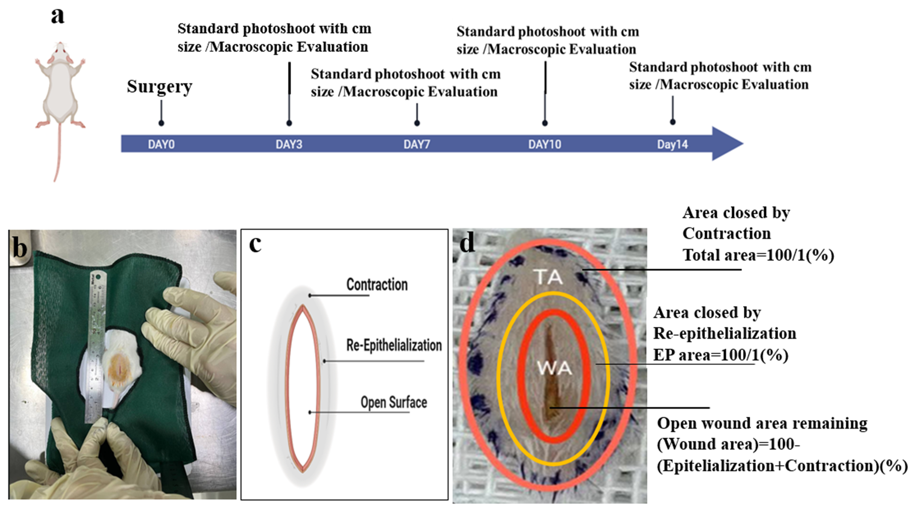

Figure 1: Wound Clouser analysis; Standardized photographs were taken on the day wounding and twice a week during the follow up. (a). Wound contraction, re-epithelization and open surface were studied as presented of initial wound area. (b, c, d)

Statistical analysis of data
All data were expressed as mean ± standard deviation¹⁹. Statistical analyses were performed with GraphPad Prism 10.1.2. One-way analysis of variance (one-way ANOVA) was used to determine the significance level between multiple groups, and the significance level was considered as *P < 0.05, **P < 0.01, ***P < 0.001.

Results
Design and characteristics of Bio-adhesive gel
The gas chromatograph-mass spectrometers (GC-MS) device was utilized to identify different substances prepared in P. Atlantic by analyzing their characteristics like pervious study²⁰. The hydro-methanolic extract of unripe fruit contained TPC, TFC, flavanols, anthocyanins, TT, CT, and hydrolyzed tannins, as determined. Comparing this extract's yield (22.15%) to similar extracts from prior studies (33.43%) and 27.10%, it had a lower yield. In the crude extract of unripe AP fruits, the TPC was found to be significant, with 75.120 mg GAE/g DM being the only significant component P. atlantica fruit and gum yielded an essential oil that was bright yellow and very light green, almost colorless, and had a penetrating fragrance. The fruit essential oil contained 12 compounds. Alpha-pinene and beta-pinene were the most abundant compounds in the essential oil of P. atlantica, accounting for most of the composition after analysis with GC-MS. Thereafter, the wound healing effect of each extract was assessed. The FTIR spectrum of Bio adhesive gel exhibited vital spectral absorbance features at (400-700cm⁻¹) is fingerprint region, also can be attributed to CH bending vibration. The assigned peaks at 1095.82,1147.09 and 1274.46cm⁻¹ are related to CO stretching vibration bands. The strong peak at 1638.57cm⁻¹ has been identified as C=O stretching vibration band. The OH stretching vibration band was determined as adsorption band at 3479.83cm⁻¹. The SEM image showed that Bio adhesive gel possessed a uniform structure. Cell Compatibility; the results of Bio-adhesive gel investigation on Human Fibroblast cells (H-Fib) (10000 cells) were treated for 24 hours (Figure 2).

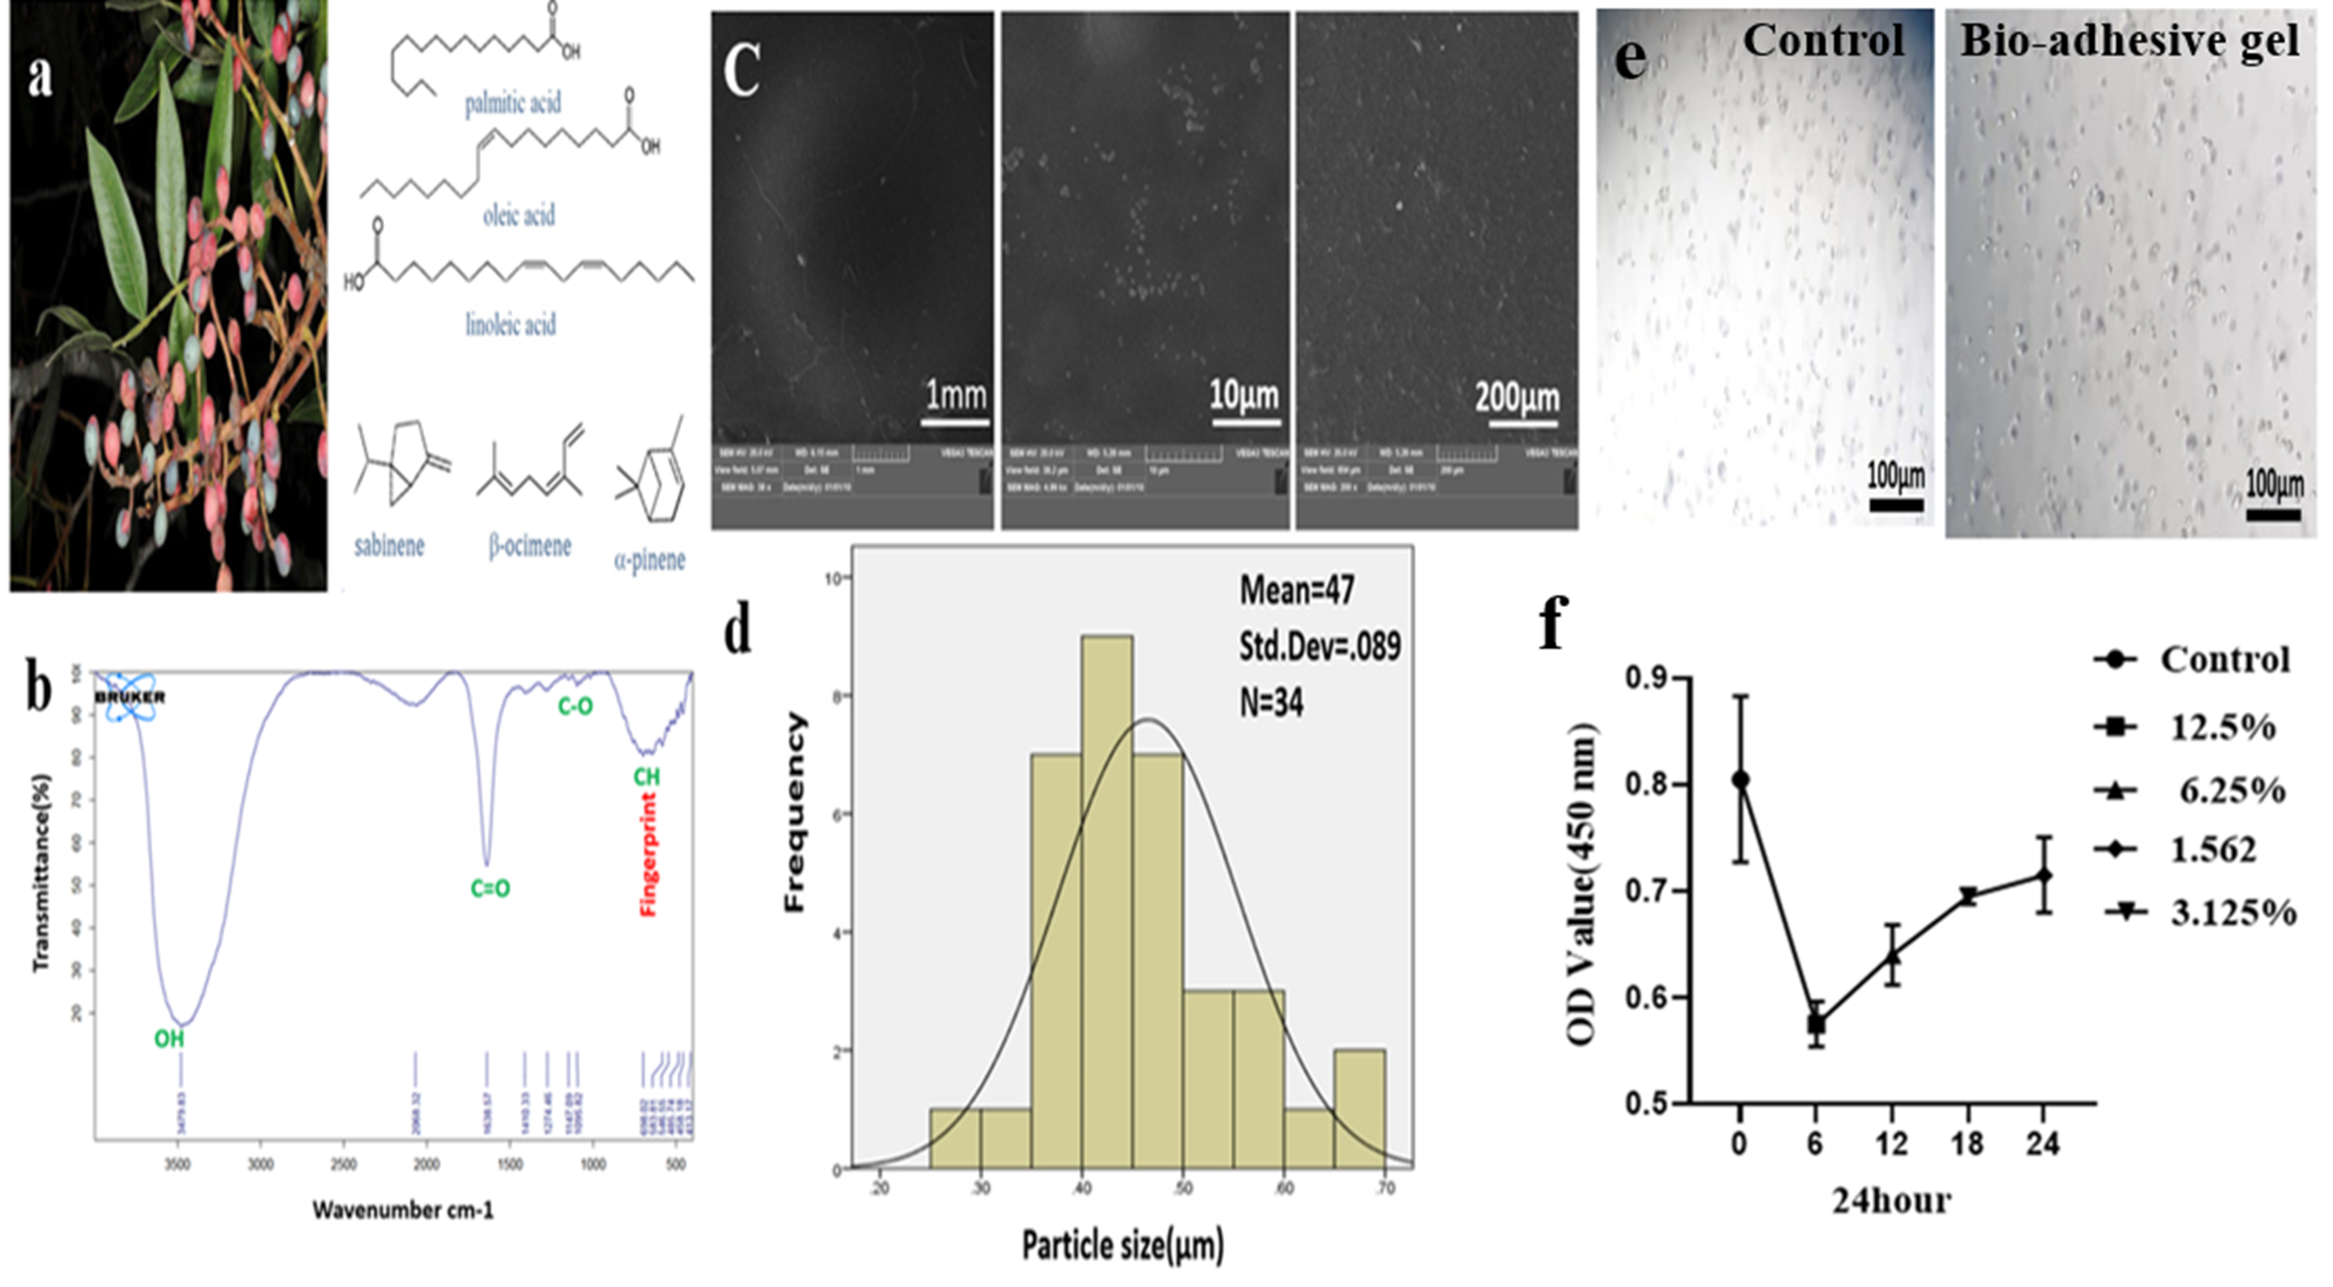

Figure 2: Photo (https://powo.science.kew.org/taxon/urn:lsid:ipni.org:names:70236-1) and their structure (https://pmc.ncbi.nlm.nih.gov/articles/PMC4702940/) isolated from Pistacia atlantica Desf. (a) FTIR spectra of scaffold substrates in different composition of Bio-adhesive gel. (b) Photomicrographs of Scanning electron micrographs , the fractured surfaces of Bio-adhesive gel. Particle Size of graph Bio-adhesive gel (Mean =47, Std. Dev =0.089, N=34). (d) MTT assay: graph depicting the cell viability percentage as a function of control and Bio-adhesive gel concentration. (e) The OD value of H-Fib cells was obtained by separating solution method for 24 hours. (f)

Skin incision adhesion and wound healing in normal mice

In addition to hemostatic performance, tissue adhesion is vital for wound repair. The in vivo adhesive capacity of Bio-adhesive gel was evaluated using a mice skin incision model, compared with a surgical suture and one commercial medical adhesives ( EPIGLUE ® containing cyanoacrylate (CA). After application, bio-adhsive gel showed obvious adhesive in the wet wound tissue, compared with the control (Figure 3a, b). After bio-adhsive gel treatment for 7 days the incised wound was tightly sealed, and bio-adhsive gel showed better adhering effect than CA. Although the wounds treated with sutures or glue healed completely, sutures or scabs were observed on the skin surface. As for CA treatment, the skin incision was well-bridged but the undegraded adhesive remained in the skin gap might hinder tissue regeneration. The effects of suture and commercial medical adhesives were similar to those previously reported ²¹ . In addition, the bio-adhesive gel showed strong performance in this in vivo regeneration test, similar to and compared to other groups. However, histological assessment was not studied in the wound models.

Wound analysis

The kinetics of animal wound healing were as follows. A no delayed wound closure in mice at group bio-adhesive gel with a 1cm full-thickness wound on the dorsum was observed after 2 weeks, compared to their suture and glue groups (Table 1) —also, animals in the group bio-adhesive gel healed in 7 days. After 2 weeks, showed almost signs of healing with wound contraction of 10%–20%, while without intervention animals (control group) at the same time point were almost heal (Table S1 and Figure 3). However, using a 1.5 cm² excisional wound in diabetic mice showed slightly faster wound closure, reaching 34% after only 10 days. On the same day, showed 84% wound closure (Figure 3) 31.91±1.74%, related to wound closure kinetics of the control mice group. Regarding the two main mechanisms of wound healing, contraction and re-epithelialization occurred in wild-type mice during the first 10 days of follow-up and contraction occurred in the last 2 weeks (Figure 3, Table S2-5).

In the process of re-epithelialization, the clinical importance of using moisture-protective dressings to improve wound healing can be understood. In the present study, bio-adhesive gel increased the migration of epidermal cells by creating a moist environment, especially in re-epithelialization. The re-epithelialization process occurred more than 50% in all groups under study, which was more pronounced on day 3. Given that re-epithelialization in a dry environment, cells dehydrate and die, which leads to the formation of a scab or crust on the wound and impaired re-epithelialization. However, in a moist environment that receives natural biological materials, epidermal cells migrate more easily on a moist surface, epithelialization is faster, and proteinases and growth factors are present for a long time. The presence of fluid in wound healing increases the proliferation of keratinocytes, the growth of fibroblasts, and the maintenance of growth factors. The ANOVA results showed that re-epithelialization occurred in all groups, and in the group receiving Bio-adhesive, the average re-epithelialization was 81.25±3.47 %on day 14. However, no significant difference was observed between the groups, P value =0.3760.

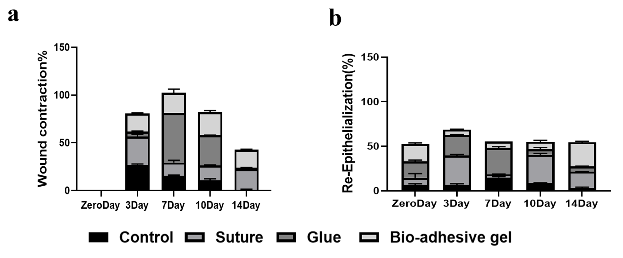

Figure 3: The two sections shown in the graph are areas of importance in the wound healing process, the first section indicating wound contraction (a) and the second section indicating epithelial re-epithelialization (b) in the Time Control, Suture, Glue, Bio adhesive gel groups at 0, 3 ,7 ,10 and 14 days

Table 1: Bio-adhesive gel wound healing kinetics
Day | Wound Contraction% | Re-Epithelialization% | Open wound Area%
zero | 0 | 58.77±3.91 | -1925.66±3.91
3 | 55.98±0.79 | 18.36±1.09 | -2444.66±1.88
7 | 63.09±3.87 | 21.95±0.05 | -2834.66±3.92
10 | 72.93±1.65 | 25±5.5 | -3231±7.15
14 | 56.69±0.65 | 81.25±3.47 | -4564.66±4.6

Note: Results are expressed as mean ± SD.

One cm full-thickness wounds on the back of the without intervention mice reached 50% wound closure in 13.7 ± 2.9 days (Figure3 ). Evaluation of wound closure revealed a strong collaborative process that facilitated epithelialization in all cases. More than 80% in bio adhesive gel group -4564.66±4.6 on day 14 (Tables 1 and Table S2-5). Due to the type of wound incision, which was longitudinal, wound contraction and the healing process were performed and evaluated until day 14. The results of ANOVA did not show any statistically significant difference in the wound closure process between the study groups, P value=0.3760.

Discussion

The primary mechanism of wound healing in rodents is wound contraction, which is not the same as in humans ^{22, 23}. Excisional wound contraction in mice can be measured, and it can occur at distinct at 0, 3 ,7, 10 and 14 days. Our data is in conformity with the previous published data ²⁴. The study suggests that wounds treated with Bio adhesive gel experience the same rate of re-epithelialization as those treated with glue ²⁵.

In models with diabetic wounds, complex surgeries are necessary to repair the rings on the skin, which can exacerbate wounds. It is a struggle to control when the strap sheds. The strap model was not used in this study due to the potential impact of significant inter-group differences on the accuracy of experimental results, as demonstrated in previous studies²⁶. Besides, when the wound area was 10 and 14, the control group had a larger wound area than the bio adhesive gel group. In this study observation period in animal experiments was extended because wounds close slower in the control group than in the bio adhesive gel group. However, the wound area in each group was statistically different in our results. Yao et al. applied a biological membrane to stop wounds from contracting ²². Using this biomaterial previously, we discovered that if the adhesive and wound repair properties were too large, it would be difficult to use it. It is probable that this caused a secondary tissue adhesive effect, but if the adhesive assets were too crucial, it would have developed at a premature point in the experiment. The research took wound contraction into account and defined experimental conditions in a mouse excisional wound model, with the use of a ring. The mice in the bio adhesive gel, Control, group had an increase in mortality rate due to the longer time it took to make the tissue than the experimental groups, although other animal treated with such as glue, Sutures and bio adhesive gel are used as a tissue repair material, the high cost of breeding and difficulty to acquire transgenic or knockout rabbits limited their application in this study ²⁷. Depending on the research purpose, visualizing, and measuring granulation and vasculature at different time points is possible. The contraction factor is simply an extra thing to consider when choosing a model and doesn't impact the model's validity.

Compared to an incision, a defect created by a full-thickness skin excision is wider and longer. The regeneration of a differentiated epidermis in excisional wounds occurs through a range from the surrounding wound margins to the center ²⁸. Chronic wounds exhibit impaired wound closure due to contraction, and we also assessed wound closure in rodents by drawing lines on their backs ^{29 .}However, the traction of the wound cone was centripetal. We evaluated the controls an area using a circular method, even though the contraction of wounds is irregular, to ensure scientifically reproducible results. The area of wound re epithelialization had a significant correlation with the area of wound reduction at various at 0, 3 ,7 ,10 and 14 days, as shown in our results. To some extent, the reduction area of wound can approximate the epithelialization area of re-epithelialized wounds. The barrier may be damaged if keratinocytes fail to maintain it, which is another significant clinical issue. By better comprehending the epithelialization process, new therapeutic approaches can be developed to speed up wound closure ²⁸. It is important for researchers to recognize the differences between various animal models and evaluate their advantages and disadvantages based on their experimental objectives. There are no perfect rodent wound models that can meet all experimental goals due to anatomical and physiological differences between animal species ^{30 .}Our study demonstrates painless mouse excisional wounds that can be a useful model for wound healing, with both contraction and reepithelialization. FTIR analysis of the material substantiates the roles of both initiators in the incorporation of bio adhesive gel, reflected in the peak around 1638.57 cm⁻¹ associated with the C = O stretching in carboxylic acid. The precursor solution contained acrylic acid based on the final product's firming agent ratio achieving a large ratio.

The ability of carboxylic acid to stick to tissue without causing irritation is a significant advantage. Their toxicity is minimal and they are compatible with several medications. Biomaterial-containing biomimetic scaffolds could help with the healing process. The skin tissue structure is supported by these scaffolds and macromolecules, such as collagen, elastin, glycosaminoglycans, proteoglycans, and connective tissue glycoproteins, are regulated, which activate important cellular pathways ³¹.Reconstructing the surrounding microenvironment by forming biochemical interactions between cells and tissues is possible with the development of biomaterials ³² .To promote wound healing, it is important to maintain a balanced skin microenvironment with moist conditions and prevent bacterial infection ³³. Tissue engineering and skin grafting have been the focus of studies on synthetic polymers to this point³⁴. Structural support and biochemical recognition have both been achieved through the incorporation of natural polymers that include chitin, chitosan, collagen, gelatin, and fibrin³⁵. In our research we used tragacanth gum. With the rapid progression of biomanufacturing technologies, integrating hydrogel applications with cutting-edge techniques is essential. The improved aids of interdisciplinary relationships over the addition of facts and skills from materials science, cell biology, biomedical engineering, and clinical medicine will lead to the creation of more complex and effective therapeutic strategies³⁶.

Organic acids have been extensively studied for the preparation of scaffolds. In addition, blends of synthetic and natural polymers have been investigated to enhance biocompatibility ^{34 .}Although biomaterial applications have shown promising results, there remain issues to be resolved, such as the lack of cell integration, low mechanical strength, and solubility.

Conclusion

This type of gel will facilitate skin regeneration in skin surgeries where skin fasteners such as sutures are used. However, it would be a good idea to investigate whether any distinct stress protection is predicted for the bio adhesive gel compared to other types of skin surgical fasteners.

Acknowledgements

No financial support was received.

Competing interests

The authors declare no competing interests.
Data availability
All supplementary data not published here will be sent to the respected readers for reasonable application. Please contact the corresponding author.

References
1. Blacklow S, Li J, Freedman BR, Zeidi M, Chen C, Mooney DJ. Bioinspired mechanically active adhesive dressings to accelerate wound closure. Sci Adv 2019;5(7):eaaw3963.
2. Cai C, Zhu H, Chen Y, Guo Y, Yang Z, Li H, et al. Mechanoactive nanocomposite hydrogel to accelerate wound repair in movable parts. ACS Nano 2022;16(12):20044-56.
3. Deng X, Gould M, Ali MA. A review of current advancements for wound healing: Biomaterial applications and medical devices. J Biomed Mater Res B Appl Biomater 2022;110(11):2542-73.
4. Salamone JC, Salamone AB, Swindle-Reilly K, Leung KX-C, McMahon RE. Grand challenge in biomaterials-wound healing. Regen Biomater 2016;3(2):127-8.
5. Yang Y, Xie W, Li S, Sun X, Yu B, Fu H, et al. Splint‐free line drawing model: An innovative method for excisional wound models. Int Wound J International Wound Journal. 2023;20(7):2673-8.
6. Bal-Ozturk A, Cecen B, Avci-Adali M, Topkaya SN, Alarcin E, Yasayan G, et al. Tissue adhesives: from research to clinical translation. Nano Today 2021;36:101049.
7. Barchitta M, Maugeri A, Favara G, Magnano San Lio R, Evola G, Agodi A, et al. Nutrition and wound healing: an overview focusing on the beneficial effects of curcumin. J Mol Sci 2019;20(5):1119.
8. Shah A, Amini-Nik S. The role of phytochemicals in the inflammatory phase of wound healing. J Mol Sci 2017;18(5):1068.
9. Tiwari R, Pathak K. Local drug delivery strategies towards wound healing. Pharmaceutics 2023;15(2):634.
10. Pachuau L. Recent developments in novel drug delivery systems for wound healing. Expert Opin Drug Deliv 2015;12(12):1895-909.
11. Chin JS, Madden L, Chew SY, Becker DL. Drug therapies and delivery mechanisms to treat perturbed skin wound healing. Adv Drug Deliv Rev 2019;149:2-18.
12. Pourreza M, Shaw JD, Zangeneh H. Sustainability of wild pistachio (Pistacia atlantica Desf.) in Zagros forests, Iran. Forest Ecology and Management 2008;255(11):3667-71.
13. Mostafaei R, Nachvak SM, Saber A, Jalilian N, Mahaki B, Salehi MG, et al. Pistacia atlantica can improve oxidative status in patients with metabolic dysfunction-associated fatty liver disease. Sci Rep 2025;15(1):32947.
14. Bozorgi M, Memariani Z, Mobli M, Salehi Surmaghi MH, Shams-Ardekani MR, Rahimi R. Five Pistacia species (P. vera, P. atlantica, P. terebinthus, P. khinjuk, and P. lentiscus): a review of their traditional uses, phytochemistry, and pharmacology. ScientificWorld Journal 2013;2013(1):219815.
15. Rashidipour M, Soroush S, Ashrafi B, Sepahvand A, Rasoulian B, Sohrabi SS, et al. Green synthesis of gold nanoparticles (AuNPs) using aqueous extract and essential oils from Satureja Khuzestanica Jamzad: evaluation of their antibacterial and antifungal activities. Biologia 2024;79(1):333-42.
16. Zhou Q, Shi Z, Xia L, Mi J, Zhang Y, Xu X, et al. Breaking the boundaries of wound closure: A novel polyurethane tissue adhesive with enhanced healing properties. J Biomed Mater Res A 2024;112(12):2301-13.
17. Masson‐Meyers DS, Andrade TA, Caetano GF, Guimaraes FR, Leite MN, Leite SN, et al. Experimental models and methods for cutaneous wound healing assessment. Int J Exp Pathol 2020;101(1-2):21-37.
18. Scherer SS, Pietramaggiori G, Mathews JC, Chan R, Fiorina P, Orgill DP. ﻿ Wound healing kinetics of the genetically diabetic mouse. Wounds 2008;20(1):18-28.
19. Esdaille CJ, Washington KS, Laurencin CT. Regenerative engineering: A review of recent advances and future directions. Regen Med 2021;16(5):495-512.
20. Bibi Y, Zia M, Qayyum A. An overview of Pistacia integerrima a medicinal plant species: Ethnobotany, biological activities and phytochemistry. Pak J Pharm Sci 2015;28(3):1009-13.
21. Deng T, Gao D, Song X, Zhou Z, Zhou L, Tao M, et al. A natural biological adhesive from snail mucus for wound repair. Nat Commun 2023;14(1):396.
22. Yao Z, Huang Y, Luo G, Wu J, He W. A biological membrane-based novel excisional wound-splinting model in mice (With video). Burns Trauma 2014;2(4):2321-3868.143625.
23. Nuutila K, Singh M, Kruse C, Philip J, Caterson EJ, Eriksson E. Titanium wound chambers for wound healing research. Wound Repair Regen 2016;24(6):1097-102.
24. Chen L, Mirza R, Kwon Y, DiPietro LA, Koh TJ. The murine excisional wound model: Contraction revisited. Wound Repair Regen 2015;23(6):874-7.
25. Scognamiglio F, Travan A, Rustighi I, Tarchi P, Palmisano S, Marsich E, et al. Adhesive and sealant interfaces for general surgery applications. J Biomed Mater Res B Appl Biomate 2016;104(3):626-39.
26. Busch N, Zinchenko A, Halle M, Geyer T. Withstand control: standing posture differentially affects space-based and feature-based cognitive control through enhanced physiological arousal. Sci Rep 2025;15(1):26347.
27. Zhu W, Chuah YJ, Wang D-A. Bioadhesives for internal medical applications: A review. Acta Biomater. 2018;74:1-16.
28. Rousselle P, Braye F, Dayan G. Re-epithelialization of adult skin wounds: Cellular mechanisms and therapeutic strategies. Adv Drug Deliv Rev 2019;146:344-65.
29. Yuk H, Varela CE, Nabzdyk CS, Mao X, Padera RF, Roche ET, et al. Dry double-sided tape for adhesion of wet tissues and devices. Nature 2019;575(7781):169-74.
30. Grada A, Mervis J, Falanga V. Research techniques made simple: animal models of wound healing. J Invest Dermatol 2018;138(10):2095-105. e1.
31. Ghatak S, Maytin EV, Mack JA, Hascall VC, Atanelishvili I, Moreno Rodriguez R, et al. Roles of proteoglycans and glycosaminoglycans in wound healing and fibrosis. Int J Cell Biol 2015;2015(1):834893.
32. Kim HS, Kumbar SG, Nukavarapu SP. Biomaterial-directed cell behavior for tissue engineering. Curr Opin Biomed Eng 2021;17:100260.
33. Zhang H, Lin X, Cao X, Wang Y, Wang J, Zhao Y. Developing natural polymers for skin wound healing. Bioact Mater 2024;33:355-76.
34. Arabpour Z, Abedi F, Salehi M, Baharnoori SM, Soleimani M, Djalilian AR. Hydrogel-based skin regeneration. Int J Mol Sci 2024;25(4):1982.
35. Ho TTP, Tran HA, Doan VK, Maitz J, Li Z, Wise SG, et al. Natural polymer‐based materials for wound healing applications. Advanced NanoBiomed Research. 2024;4(5):2300131.
36. Lu P, Ruan D, Huang M, Tian M, Zhu K, Gan Z, et al. Harnessing the potential of hydrogels for advanced therapeutic applications: current achievements and future directions. Signal transduction and Target Ther. 2024;9(1):166.

