**Case Report**

**Ipsilateral Intact Concha as a Rotational Flap for Reconstruction of Congenital Auricular Defect**

Seyed Esmail Hassanpour 1, Arian Karimi Rouzbahani 2,3, Zahra Goudarzi 4,5, Mahya Aliakbari 6, Hormoz Mahmoudvand 7*

1. Department of Plastic and Reconstructive Surgery, Educational Hospital of 15th Khordad, Shahid Beheshti University of Medical Sciences, Tehran, Iran
2. Student Research Committee, Lorestan University of Medical Sciences, Khorramabad, Iran
3. USERN Office, Lorestan University of Medical Sciences, Khorramabad, Iran
4. Bachelor of Nursing Student,scientific Research of Committee, School of Nursing and Midwifery, Tehran University of Medical Sciences, Tehran , Iran
5. Students' Scientific Research Center, Tehran University of Medical Sciences, Tehran, Iran
6. Student Research Committee, Bushehr University of Medical Sciences, Bushehr, Iran
7. Department of Surgery, Faculty of Medicine, Lorestan University of Medical Sciences, Khorramabad, Iran

*Corresponding Author

Hormoz Mahmoudvand, MD.

Department of Surgery, Lorestan University of Medical Sciences, Khorramabad, Iran. Tel.: +989166616195

Email: dr.mahmoudvand@gmail.com

**ABSTRACT**

The chondrocutaneous sandwich of the external ear has a delicate and complicated design, making partial ear reconstruction a challenging task for plastic surgeons. In this study, 12 patients who had surgery utilizing the conchal rotational flap and grafting approach were monitored for 1 year after surgery. The upper third of ear deformities have been repaired using a cartilaginous composite flap. Following the procedure, a year later, there were no signs of a seroma, infection, hematoma, deformity, or flap ischemia. All patients had pleasing cosmetic outcomes. The findings of this study suggest that full-thickness upper third auricular abnormalities be repaired utilizing this combination method.

**KEYWORDS**

Ear reconstruction; Conchal rotation flap; Upper third ear defect

INTRODUCTION

Congenital auricular defects include a wide range of disorders that can cause involvement of the outer, middle, or both parts 1-4. These abnormalities have a lot of severity and morphological diversity, which include different disorders from contraction, anotia, and transparency of the ear to microsia 2-4. Severe abnormalities such as microtia are rare and occur between 0.8 and 2.4 per 10,000 live births 2. In addition, congenital auricular defects may cause mental disorders because these abnormalities affect the overall beauty of the face and can endanger a person's mental health 2,3,5,6.

The concha is the central part of the external ear, which consists of cartilage, subcutaneous tissue, and thin skin. The presence of concha is important in maintaining the normal structure of the external ear and guiding the sound waves towards the external auditory canal 7-9. This important structure contains a significant amount of cartilage. In some reconstructive surgeries, this cartilage is used for transplantation. Usually, the scar of the transplant in this place does not affect the overall structure of the external ear and the person's overall beauty. Local flaps are also used in external ear reconstruction, recommended regarding safety, function, and aesthetics 9.

Auricular defects require treatment due to causing auditory and aesthetic disorders. There is no fixed protocol for the treatment of these abnormalities, but several treatment methods are available. Celsus probably provided the first definition of ear reconstruction 3,5. and Neumann used the concept of tissue expansion for the first time in ear reconstruction 10. Various surgical techniques are used for ear reconstruction, but ear reconstruction is still one of the challenges of plastic surgeons because the ear has a complex and delicate anatomy, and in this surgery, in addition to preserving the hearing function of the ear, aesthetic aspects and the patient's expectations from the surgery are considered 11-14. Taking into account the size of the defect, the location of the defect, and the tissues involved, various surgical techniques, advanced cartilage flaps, or modified techniques are used 5,12,14. Today, according to the progress of biotechnology and bioengineering, new treatments will be introduced in the field of ear reconstruction 12.

In this case study, we discuss patients with congenital auricular defects who underwent ear reconstruction surgery through a rotary concha flap.

CASE PRESENTATION

In this study, 12 patients with congenital auricular defects were referred to Ashair Hospital in Khorram Abad, Lorestan Province, out of which 7 were men and 5 were women. These people were in the age range of 12 to 43 yr. In this study, 12 patients underwent surgery using the rotary flap technique from the existing conca, and skin grafting was performed on the posterior surface of the flap and the anterior surface of the donor site. The ipsilateral concha may be used as a composite skin-cartilage flap. This method can be used for upper-third ear defects and should be used only when the antihelical support remains intact. Informed consent was obtained from the patients.

Reconstruction of the upper third of the ear with a chondrocutaneous composite flap based on the crus helix has provided a successful method with satisfactory aesthetic results and fewer complications. Twelve patients were operated on with this technique. In follow-up during the first year after the operation, seroma did not occur, grafting was normal without necrosis, and suture lines were normal without discharge or bleeding. No major deformities were observed in the operated ears. There was no subsequent operation for revision or secondary reconstruction. Aesthetic results were acceptable to patients. Table 1 shows the status and satisfaction of the patients, examined during the one-year follow-up period.

**Table 1:** The condition of patients after surgery and their level of satisfaction

|  |  |  |  |
| --- | --- | --- | --- |
| questions | Yes (Number of responses) | No (Number of responses) | No response |
| Are you satisfied with the appearance of your ears after surgery? | 12 | 0 | 0 |
| Do you feel better about yourself after surgery? | 8 | 2 | 2 |
| Did the people around you give you positive feedback about your ears after the surgery? | 4 | 3 | 5 |
| Did the people around you give you negative feedback about your ears after the surgery? | 0 | 12 | 0 |
| Did you have abnormal discharge around your ears after the end of the post-surgery care period? | 0 | 12 | 0 |
| Have you experienced symptoms of infection such as purulent discharge or fever after surgery? | 0 | 12 | 0 |
| Have you had a hematoma (blood collected under the skin) after ear surgery? | 0 | 12 | 0 |

Pictures of patients: Picture number one, picture A is before surgery and pictures B to I are after surgery and picture number two, photos A and B are related to before surgery and photos c and D are related to after surgery.

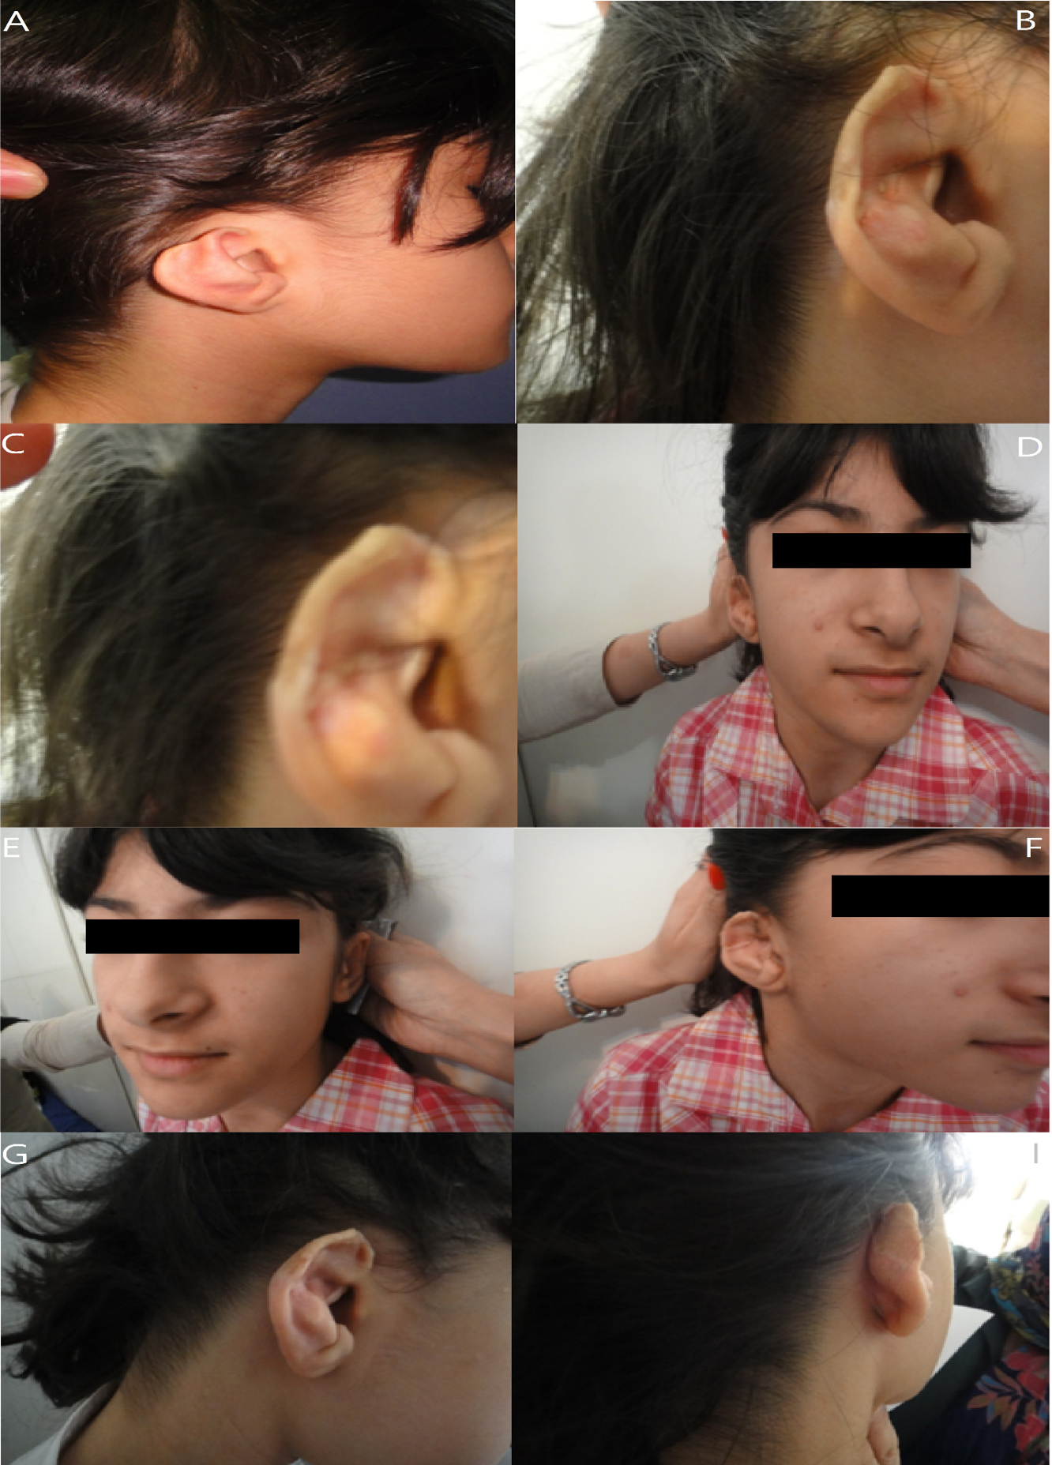

**Figure 1:** Picture of a 12-year-old girl with auricular defect, before surgery (1A), After surgery, it has arranged according to time and recovery process. (1B to 1I)

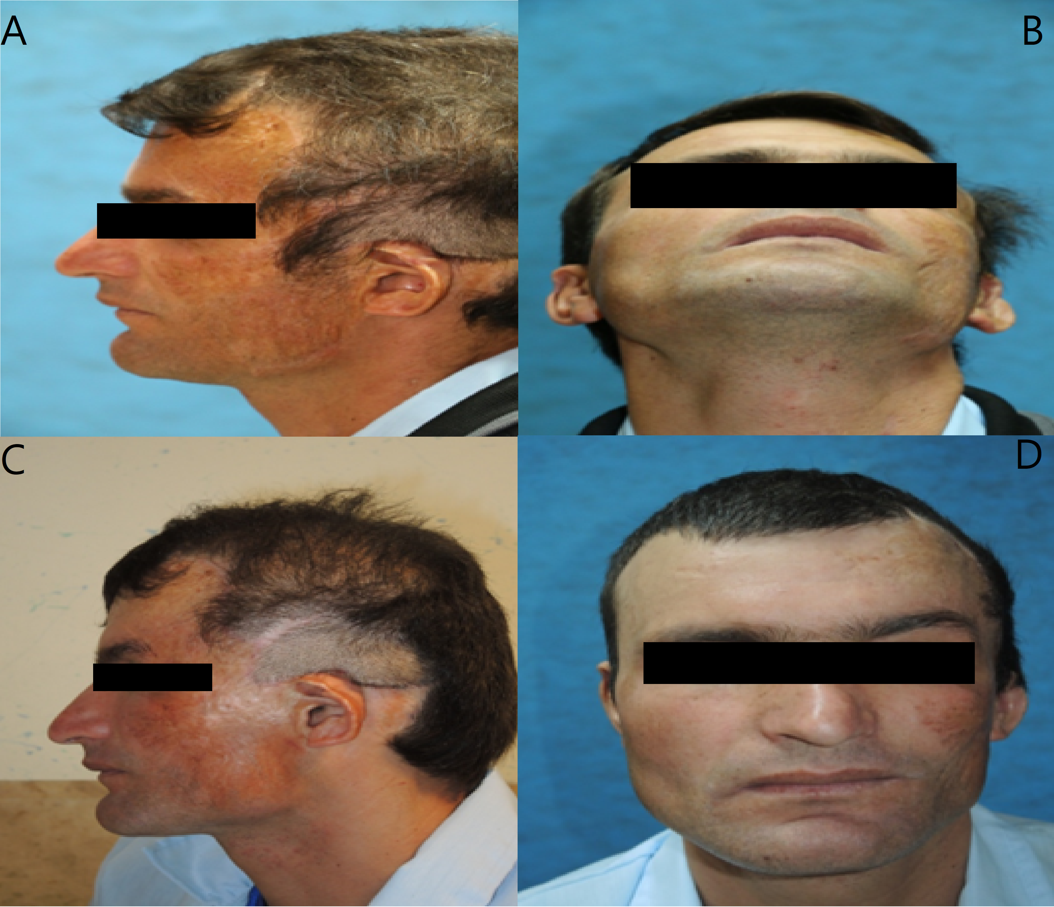

**Figure 2:** The picture of a 34-year-old man who suffered from ear deformity and underwent rotary flap surgery. Before surgery. (2A, 2B) after surgery (2C, 2D)

DISCUSSION

Ear reconstruction surgery requires high precision and finesse because in addition to functional disorders, cosmetic disorders are also considered. A small abnormality in the ears can affect the overall beauty of the face and cause a lot of mental burden for a person. Ear reconstruction is one of the challenges of plastic surgeons and this surgery requires the mastery of different techniques 3,5,11. One of the surgeries performed to repair ear defects is flaps, in which skin grafting is performed with partial and complete grafts from behind the ear to repair the defective area 10,15. The flap can be considered one of the main methods of ear reconstruction 16. In This method, the upper, middle, and lower third of the ear is reconstructed, although this method is less useful in the treatment of defects of the middle third of the ear 10.

In a case report study, Zhicheng et al. reported the condition of a 24-year-old woman with Conca's defect, caused by a cartilage graft used for rhinoplasty, and in this study, a revolving-door (RD) flap was used for treatment and after 6 months of follow-up, the results of the study indicate a suitable aesthetic and functional level 9.

In another study, a local flap was used, if the diameter of the defect in the ear is more than 15 mm or if it is located in the upper part of the concha, the postauricular subcutaneous pedicle island flap is used and if the diameter is less than 15 mm or the damage is in the lower area of the concha, the preauricular displacement flap is used. Then the subjects were followed up for 35 months and all patients were completely satisfied with the result of the surgery in terms of function and aesthetics 8.

Moreover, a study on 75 patients undergoing ear reconstruction, and in patients whose size of the defect area is 15 to 20 mm, they were treated with primary closure. In addition, the patients who have a defect larger than 40 to 55 mm have used the reverse retro auricular flap and the results of this study indicate that the patients are satisfied with the treatment and that the treatment has been successfully performed 5.

In this study, 12 patients referred to Khorramabad Nomadic Hospital underwent rotary flap surgery and fortunately, minor defects cause fewer cosmetic problems and hair may cover the area. For upper ear defects smaller than 2.8 cm, the spiral advancement technique is beneficial and complications are rare. A variant of this flap that separates from the anterior and posterior spiral surfaces maximizes mobility at the expense of tissue survival. In another variation, more than forty years ago, the viability of the flap is not compromised, but movement is significantly restricted because the posterior skin remains intact. Large upper third defects are often controlled by contralateral cartilage grafts and posterior auricular skin flaps. In cases of insufficient graft donor resources, the use of composite pedicle flap is recommended. A preauricular flap designed at the auricle-facial junction with the pedicle up or down may cover some small antihelix defects. Then patients underwent follow-up, during which no serious complications were reported and the suture lines were free of discharge and bleeding. Moreover, the patients did not need secondary intervention and the patients were at an acceptable level in terms of aesthetics.

CONCLUSION

Concha flap for managing upper third defects of the ear is a confident plan with good results. There are several techniques to reconstruct the upper third defect and factors such as the size of the defect and the availability of skin grafts mainly determine the priority of options in each case.

ACKNOWLEDGEMENTS

This work has been completed without any technical support from other people or organization

CONFLICT OF INTEREST

The authors declare that there is no conflict of interest.

REFERENCES

1. Siegert R. Combined reconstruction of congenital auricular atresia and severe microtia. In: Aesthetics and Functionality in Ear Reconstruction 2010 (Vol. 68, pp. 95-107). Karger Publishers.

2. Joukhadar N, McKee D, Caouette-Laberge L, Bezuhly M. Management of congenital auricular anomalies. *Plastic and Reconstructive Surgery* 2020;**146**(2):205e-16e.

3. Siegert R, Magritz R. Otoplasty and auricular reconstruction. *Facial Plastic Surgery* 2019; **35**(04):377-86.

4. Olshinka A, Yaacobi D, Ad-El D. Congenital convex concha-An unfamiliar auricular deformation and a novel non-surgical management protocol. *Otorhinolaryngol Head Neck Surg* 5: doi: 10.15761/OHNS.1000229

5. Ghassemi A, Modabber A, Talebzadeh M, Nanhekhan L, Heinz M, Hölzle F. Surgical management of auricular defect depending on the size, location, and tissue involved. *J Oral Maxillofacial Surg* 2013;**71**(8):e232-42.

6. Jiang C, Chen B, Lu L, Yan X, Yi B, Shi R. Repair of exposure and fracture of the porous high-density polyethylene framework after ear reconstruction. *Head & Face Medicine* 2022; **16**;18(1):41.  
7. Zhu J, Zhao H, Wu K, Lv C, Sun MY, Wang YC, Xing X, Xue CY. Reconstruction of auricular conchal defects with local flaps. *Medicine* 2016; **95**(46):e5282.

8.Harounian JA, Fundakowski C. Reconstruction of the conchal bowl. Operative Techniques in Otolaryngology-Head and Neck Surgery. 2017; **28**(2):125-9.

9.Liu X, Zhou T, Zhao T, Xu Z. Reconstruction of an iatrogenic anterior conchal defect with a revolving-door flap. *BMC Surgery* 2021; **21**(1):1-4.

10. Chana JS, Grobbelaar AO, Gault DT. Tissue expansion as an adjunct to reconstruction of congenital and acquired auricular deformities. British journal of plastic surgery. 1997; 50(6):456-62.

11. Changchen W, Xiaosheng L, Bin W, Meirong Y, Ye Z, Bo P. Repair of damage to the skin flap during total auricular reconstruction with tissue expansion. Int J Pediatr Otorhinolaryngol 2020; **139**:110470.

12. Ebrahimi A, Kazemi A, Rasouli HR, Kazemi M, Motamedi MH. Reconstructive surgery of auricular defects: an overview. *Trauma Mon* 2015;20(4): e28202.

13. Storck K, Staudenmaier R, Buchberger M, Strenger T, Kreutzer K, Von Bomhard A, Stark T. Total reconstruction of the auricle: our experiences on indications and recent techniques. *Biomed Res Int* 2014 14;2014: 373286.

14. DePamphilis MA, Buta MR, Bojovic B, Driscoll DN. Pediatric postburn ear reconstruction of significant cartilage defects. *J Burn Care Res* 2023; **44**(4):837-44.

15. Li G, Zhang B, Ding W, Ouyang H, Long X, Fu A, Liu X. Reconstruction of Concha-type Microtia Using A Delayed Postauricular Skin Flap. *Plast Reconstr Surg* 2024;**153**(2):407e-410e.

16. Chen X, Zhang R, Zhang Q, Xu Z, Xu F, Li D, Li Y. Auricular reconstruction in microtia for soft tissue coverage: Flap pocket method versus expansion method. *Int J Pediatr Otorhinolaryngol* 2022; **152**:110987.